**CHAPTER 3**

# SOFTWARE REQUIREMENT SPECIFICATIONS

## 3.1 LANGUAGE USED FOR IMPLEMENTATION

* HTML and PHP programming languages are used.
* Operating Platform: WINDOWS 10
* Web Browser: Chrome
* Rear End: Sql Server
* Software: XAMPP, MySQL
* Front End: HTML and PHP Programming language

Hyper Text Markup Language (HTML) is the standard mark-up language for creating web pages and web applications. With Cascading Style Sheets (CSS) and JavaScript it forms a triad of cornerstone technologies for the World Wide Web.

PHP is a server-side scripting language designed primarily for web development but also used as a general-purpose programming language.

## 3.2 PLATFORM USED FOR IMPLEMENTATION

* Hardware Requirements
* Processor: Intel P4 1.5GHz or Above
* Hard Disk: 5 GB
* Memory: 1 GB RAM

**CHAPTER 4**

# ANALYSIS AND DESIGN

This part contains result and snapshots of the project.

## 4.1 USER LOGIN PROCESS:

* In Medical Clinic, the user has to first register.
* This includes the Username, Password. After submitting these data, the user will be directed to the Home page whereby the user information is to be submitted as shown in the fig 4.1

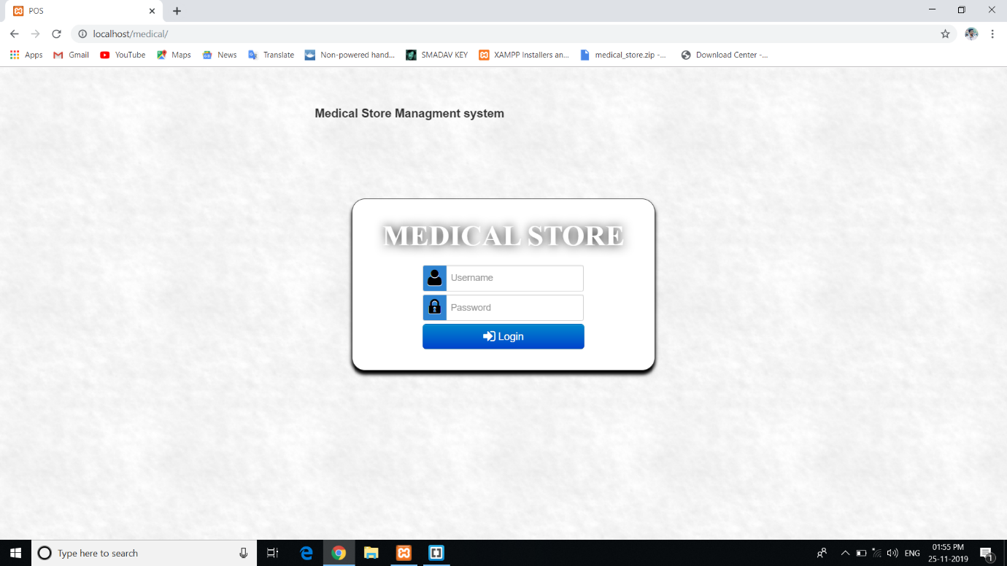

**Fig 4.1: User Login Process**